Power supplies :
Advanced Technology (AT) – This is the original power supply for legacy computer systems now considered obsolete.
- AT Extended (ATX) – This is the updated version of the AT but still considered to be obsolete.
- ATX12V – This is the most common power supply on the market today. It includes a second motherboard connector to provide dedicated power to the CPU. There are several versions of ATX12V available.
- EPS12V – This was originally designed for network servers but is now commonly used in high-end desktop models.

Mother bord :

Central Processing Unit (CPU) - This is considered the brain of the computer.
- Random Access Memory (RAM) - This is a temporary location to store data and applications
- Expansion slots - These provide locations to connect additional components.
- Chipset - This consists of the integrated circuits on the motherboard that control how system hardware interacts with the CPU and motherboard. It also establishes how much memory can be added to a motherboard and the type of connectors on the motherboard.
- Basic input/output system (BIOS) chip and Unified Extensible Firmware Interface (UEFI) chip - BIOS is used to help boot the computer and manage the flow of data between the hard drive, video card, keyboard, mouse, and more. In modern computers BIOS has been replaced by UEFI. UEFI specifies a different firmware for boot and runtime services. Firmware is programming that allows a computer operating system to control the hardware.
Integrated Drive Electronics (IDE) is an older standard interface for connecting disk drives to the motherboard. IDE uses a 40-pin connector. Each IDE interface supports a maximum of two devices.

SATA, or Serial Advanced Technology Attachment (ATA), is a disk drive interface used for connecting optical drives, hard drives, and solid-state drives to the motherboard. SATA supports hot swapping, which is the ability to replace devices without powering off the computer.

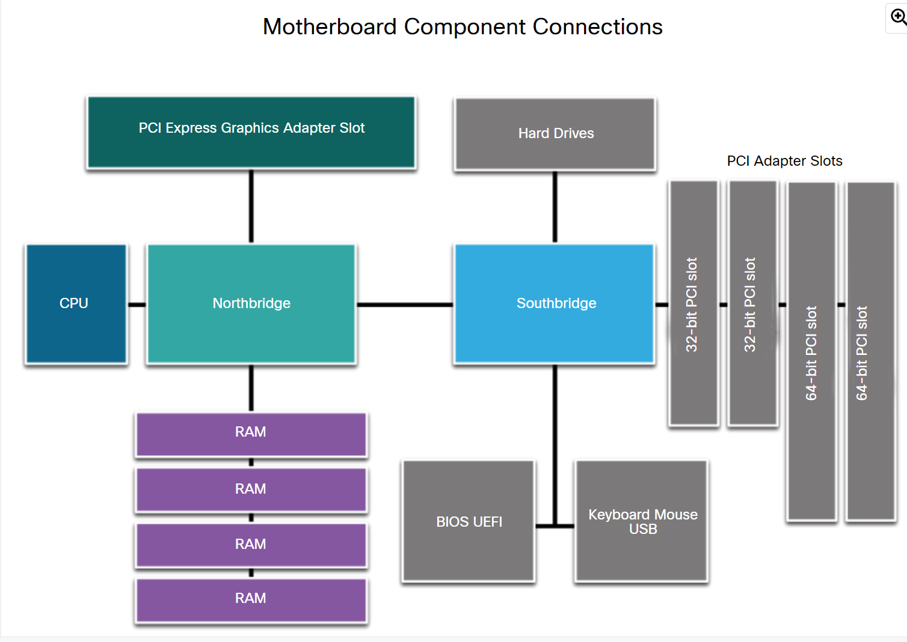
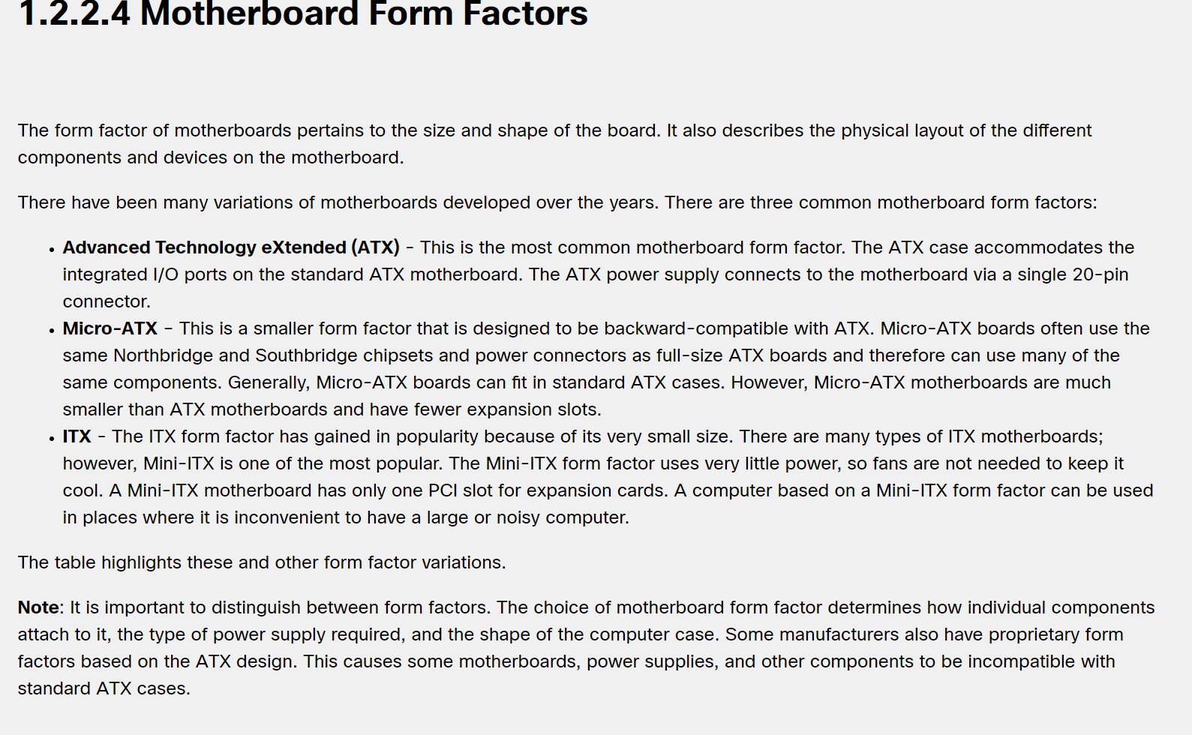
Cpu :

Pin Grid Array (PGA)
In PGA architecture (shown below), the pins are on the underside of the processor package and is inserted into the motherboard CPU socket using zero insertion force (ZIF). ZIF refers to the amount of force needed to install a CPU into the motherboard socket or slot.

Land Grid Array (LGA)
In an LGA architecture (shown below), the pins are in the socket instead of on the processor.

Refroidisement :
Heat Sink (Passive Cooling)

Case Fan (Active Cooling)

memoire :

ROM
Read-only memory chips. Information is written to a ROM chip when it is manufactured. A ROM chip that cannot be erased or re-written is now obsolete. The term ROM still tends to be used generically for any read-only memory chip type.

PROM
Information on a programmable read-only memory chip is written after it is manufactured. PROMs are manufactured blank and then can be programmed by a PROM programmer when needed. Generally, these chips cannot be erased and can only be programmed once.

EPROM
Erasable programmable read-only memory is non-volatile but can be erased by exposing it to strong ultraviolet light. EPROMs usually have a transparent quartz window on the top of the chip. Constant erasing and reprogramming could ultimately render the chip useless.

EEPROM
Information is written to an electrically erasable programmable read-only memory chip after it is manufactured and without removing it from the device. EEPROM chips are also called Flash ROMs since its contents can be "flashed" for deletion. EEPROMs are often used to store a computer system's BIOS.

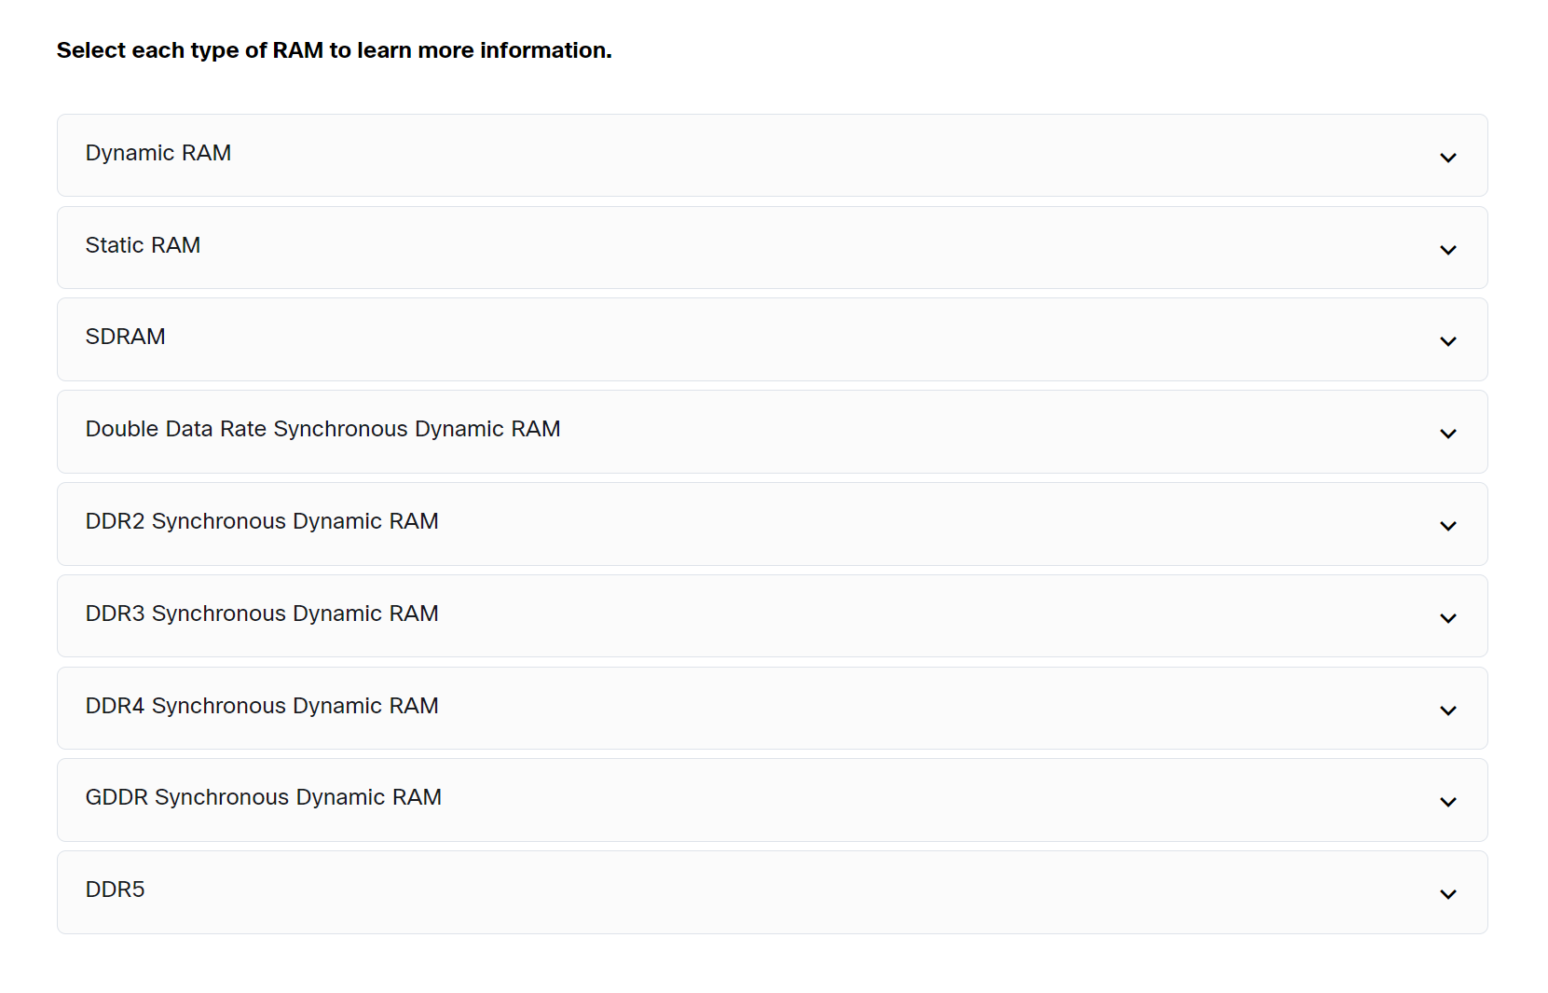
Sd
sd

DIP
Dual Inline Package is an individual memory chip. A DIP has dual rows of pins used to attach it to the motherboard.

SIMM
Single Inline Memory Module is a small circuit board that holds several memory chips. SIMMs have 30-pin or 72-pin configurations.

DIMM Memory
Dual Inline Memory Module is a circuit board that holds SDRAM, DDR SDRAM, DDR2 SDRAM, DDR3 SDRAM, and DDR4 SDRAM chips. There are 168-pin SDRAM DIMMs, 184-pin DDR DIMMs, 240-pin DDR2 and DDR3 DIMMs, and 288-pin DDR4 DIMMs.

SODIMM
Small Outline DIMM has a 72-pin and 100-pin configurations for support of 32-bit transfers or a 144-pin, 200-pin, 204-pin, and 260-pin configurations for support of 64-bit transfers. This smaller, more condensed version of DIMM provides random access data storage that is ideal for use in laptops, printers, and other devices where conserving space is desirable.

Adapter card :

Wireless NIC - A wireless NIC connects a computer to a network using radio frequencies.
- Capture card - Capture cards send a video signal to a computer so that the signal can be recorded to a storage drive with video capture software.
- TV tuner card - These provide the ability to watch and record television signals on a PC by connecting a cable television, satellite, or antenna to the installed tuner card.
- Universal Serial Bus (USB) controller card – Provides additional USB ports to connect the computer to peripheral devices.

PCI
Peripheral Component Interconnect is a 32-bit or 64-bit expansion slot. It is currently found in few computers. PCI expansion slots have become mostly obsolete.

Mini-PCI
This is smaller version of PCI found in some laptops. Mini PCI has three different form factors; Type I, Type II, and Type III.

PCI-X
PCI eXtended is an updated version of the standard PCI. It uses a 32-bit bus with higher bandwidth than the PCI bus. PCI-X can operate up to four times faster than PCI. PCI-X expansion slots have become mostly obsolete.
PCIe
PCI Express is a 64-bit parallel interface that is backward compatible with 32-bit PCI devices. PCIe is a serial point-to-point connection with a different physical interface that was designed to supersede both PCI and PCI-X. There are four sizes (lengths): PCI Express x1, PCI Express x4, PCI Express x8, and PCI Express x16.'PCIe x4' connections have four data lanes. 'PCIe x8' connections have eight data lanes. 'PCIe x16' connections have sixteen data lanes.
Riser Card
A riser card can be added to a computer to provide additional expansion slots for more expansion cards.
AGP
Accelerated Graphics Port (AGP) was a high speed slot for attaching an AGP video card. The AGP has been superceeded by PCI. Few motherboards still use this technology today.
Magnetic Media Storage

Semiconductor Storage

